Techniques
Collapsing a text into alphabetical order (aka ‘Fridge Magnets’)
One of the most useful things you can do with Word is to reduce a text to its component parts and arrange them alphabetically. So that The Tyger, for example, looks like this:

And And And and and anvil, art. aspire? beat, began brain bright, bright, burning burning Burnt chain, clasp! Could Could dare dare Dare Dare deadly deeps Did Did distant down dread dread dread eye, eye, eyes! fearful fearful feet! fire fire! forests forests frame frame furnace grasp, hammer! hand hand hand! hand, he he he heart heart? heaven his immortal immortal In In In In its Lamb made make night: night; of of of of On or or or see shoulder, sieze sinews skies. smile spear stars symmetry symmetry! tears: terrors the the the the the the the the the the the the the thee! their their thine threw thy thy thy thy thy to to twist Tyger Tyger Tyger Tyger, was water'd What what what What what what What what What what what What what What when When who wings with work

Instructions

Make sure it is a ‘clean’ text – i.e. not directly copied from the internet (see Troubleshooting below). Select the text to be collapsed.

Go to ‘Replace’ in the Home menu (shortcut Ctrl H).

Type a space in the ‘Find what’ box.

Type ^p in the ‘Replace with’ box (NB: a lower case p).
Click on ‘Replace All’. This will put the text into a long thin line by replacing all the spaces between words with a new paragraph.
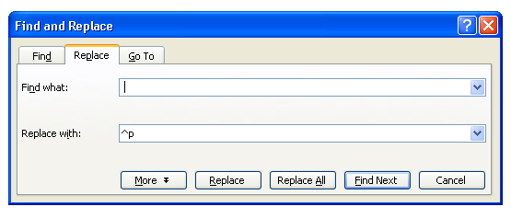
Select ‘Sort’ in the Home menu (the A / Z icon)
Click OK (ignore other options) and this should sort your words alphabetically.

You are now going to reverse the previous procedure, so go back to ‘Replace’ (Ctrl H)
Type ^p in the ‘Find what’ box. (Make sure you have deleted the space you typed earlier.)
Type a space (or more if you want to spread the words out) in the ‘Replace with’ box
Click on ‘Replace All’
This will put the text back into a paragraph with the words in alphabetical order. If you want to tidy it, Shift and F3 will enable you to remove capital letters and you can use ‘Find’ and ‘Replace’ to remove punctuation marks.

Troubleshooting
When copying a text from the internet, a quick and simple way to ensure it is ‘clean’ is to copy it into Notepad. Then copy it from Notepad into Word.
If things don’t go right first time, check you have followed the instructions exactly. An extra space somewhere will upset the Replace action.
.
Why do it? Here are a few suggestions.
Present students with the collapsed version of a poem before they encounter it as a ‘GCSE poem’. Let them become familiar with the words and suggest what the poem might be about, how does it ‘feel’? Ask them to use some of the words (as in using fridge magnets) to create a poem (or any other piece of writing). When they read the actual poem, they will already have a familiarity with it.
Look at repetitions. Sort words into categories. What ideas are thrown up about the text? I have found this revealing for poems that I already know quite well.
Again, before reading or hearing a poem, look at the words used and try to guess when it was written.
Use the words simply as a creative writing activity. This works well with pupils who are reluctant writers, especially if they can do it using Word and can just drag and drop (just like fridge magnets).
© Trevor Millum and Chris Warren 2021

