Eden Rock – Charles Causley
This is a deceptively simple poem, written in a casual, conversational tone. Yet it always leads to questions. Firstly, the enigmatic last line, about which you would dearly love to ask the writer what was meant. This then sends you (and your students) back to consider the poem again.
Before doing so, why not use a word processed version to strip out the line endings. Use Find and Replace and Find ^p. Replace it with a space or two. Replace All will present you with a block of text which, if you change capitals to lower case where appropriate, is, at least on the surface, a very easily read piece of prose.
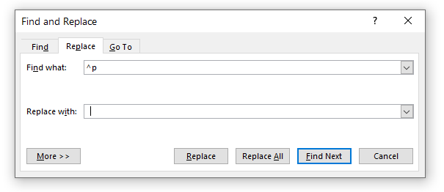
You can of course achieve the same aim by writing the poem out; it doesn’t take long and it might help students to become familiar with it.
With the rearranged text in front of them, ask students to underline anything worth questioning. For example:
- They are waiting - why not ‘They were waiting’?
- Same suit
- Still two-years-old
- The same three plates
- I hear them call
- I had not thought it would be like this
In groups, ask them to discuss the effect of these word choices and the effect of the use of the present tense.
Then, consider, why or how has this picture come into his mind? It’s not necessary to come up with any definite answers.
Time for a spot of creative writing. Ask students to recall a childhood memory and to describe it in any way they like: prose, poetry, disjointed phrases… Suggest using third person instead of first and see if that changes things.
If students are willing to share their writing, have a few pieces read out or offer to read them yourself.
The poem describes a very precise scene. Yet, if his mother is 23, the boy is not likely to have been very old. How reliable a memory would it be? Did he discover a photograph? In which case, who took it? Did the scene actually ever take place? Has he imagined it and slotted familiar items into the picture he created? Is the whole thing made up – after all, writers make things up all the time!
Some of the commentaries on this poem read a great deal into the image of the river and ‘crossing over’. How far do students agree with these interpretations? And finally, of course, what is the ‘it’ in the last line?
Growing old | Missing your parents | Facing up to mortality | Dealing with vivid memories | Nostalgia / Regret

Reassure students that it is perfectly acceptable in an examination response to not have a definite answer. In fact, an answer which goes along the lines of ‘On the one hand….on the other’ is to be preferred, especially if the thoughts are those of the student, not the teacher or a website.
Post Script
There is a recording of Causley reading the poem on The Poetry Archive. At the end he says “Somebody asked me the other day where Eden Rock is. I’ve no idea. I made it up.” Also from The Poetry Archive: “…the moving elegy to his parents, ‘Eden Rock’. As he says in the last line of this poem “I had not thought that it would be like this”, a fitting epitaph for a poet who continued to be surprised by the world throughout his long life.” It also informs us that when he was only seven his father died from wounds sustained during the First World War.
© Trevor Millum 2022

